Week -1
1.Hello.c

#include<stdio.h>
int main()
{
printf("Hello Linux\n");
return 0;
}
Compile: gcc hello.c -o hello
./hello
OUTPUT:
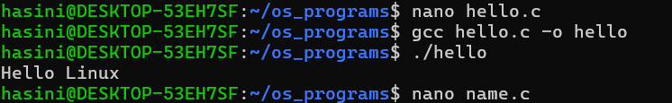

2. Read User Name

#include<stdio.h>
int main()
{
char name[30];
printf("Enter your name: ");
scanf("%s",name);
printf("Welcome %s\n",name);
return 0;
}
Output:
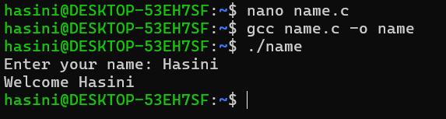

3. Display Process ID

#include<stdio.h>
#include<unistd.h>
int main()
{
printf("Process ID = %d\n",getpid());
return 0;
}
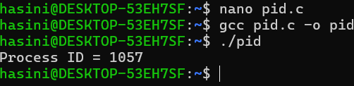

4. #include<stdio.h>
#include<unistd.h>
int main()
{
fork();
printf("Hello\n");
return 0;
}
OUTPUT:
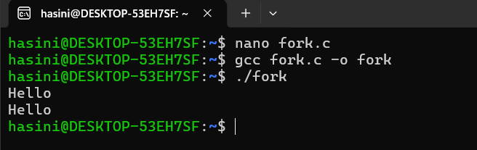

- Parent and Child
#include<stdio.h>
#include<unistd.h>
int main()
{
pid_t pid;
pid=fork();
if(pid==0)
{
printf("I am Child Process\n");
}
else
{
printf("I am Parent Process\n");
}
return 0;
}
OUTPUT:
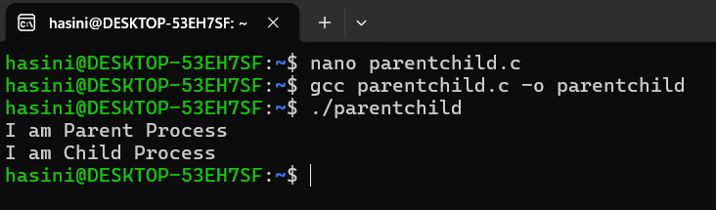

6.Display parent and Child PID
#include<stdio.h>
#include<unistd.h>
int main()
{
pid_t pid;
pid=fork();
if(pid==0)
{
printf("Child PID = %d\n",getpid());
printf("Parent PID = %d\n",getppid());
}
else
{
printf("Parent PID = %d\n",getpid());
}
return 0;
}
OUTPUT:
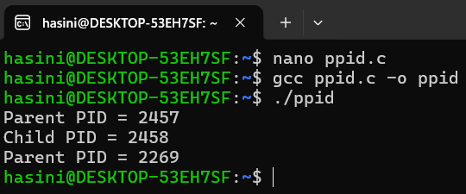

7.Wait()
#include<stdio.h>
#include<unistd.h>
#include<sys/wait.h>
int main()
{
pid_t pid;
pid=fork();

if(pid==0)
{
printf("Child Running\n");
}
else
{
wait(NULL);
printf("Parent Running After Child\n");
}
return 0;
}
OUTPUT:
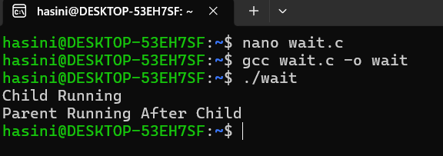
8. Wait two()

#include<stdio.h>
#include<unistd.h>
int main()
{
printf("Before exec()\n");
execlp("ls","ls",NULL);
printf("After exec()\n");

return 0;
}
OUTPUT:
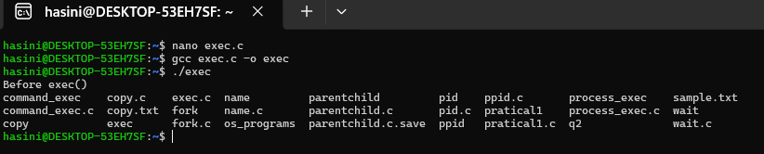

- fork() + exec()

#include<stdio.h>
#include<unistd.h>
#include<sys/wait.h>
int main()
{
pid_t pid;
pid=fork();
if(pid==0)
{
execlp("date","date",NULL);
}
else
{
wait(NULL);

printf("Child Completed\n");
}
return 0;
}
OUTPUT: 